**ORACLE DATABASE -SQL**

Select * From User_Tables;

Exp: Show all tables in a database

Note: It’s also called **Data Dictionary Table**

**Example:**

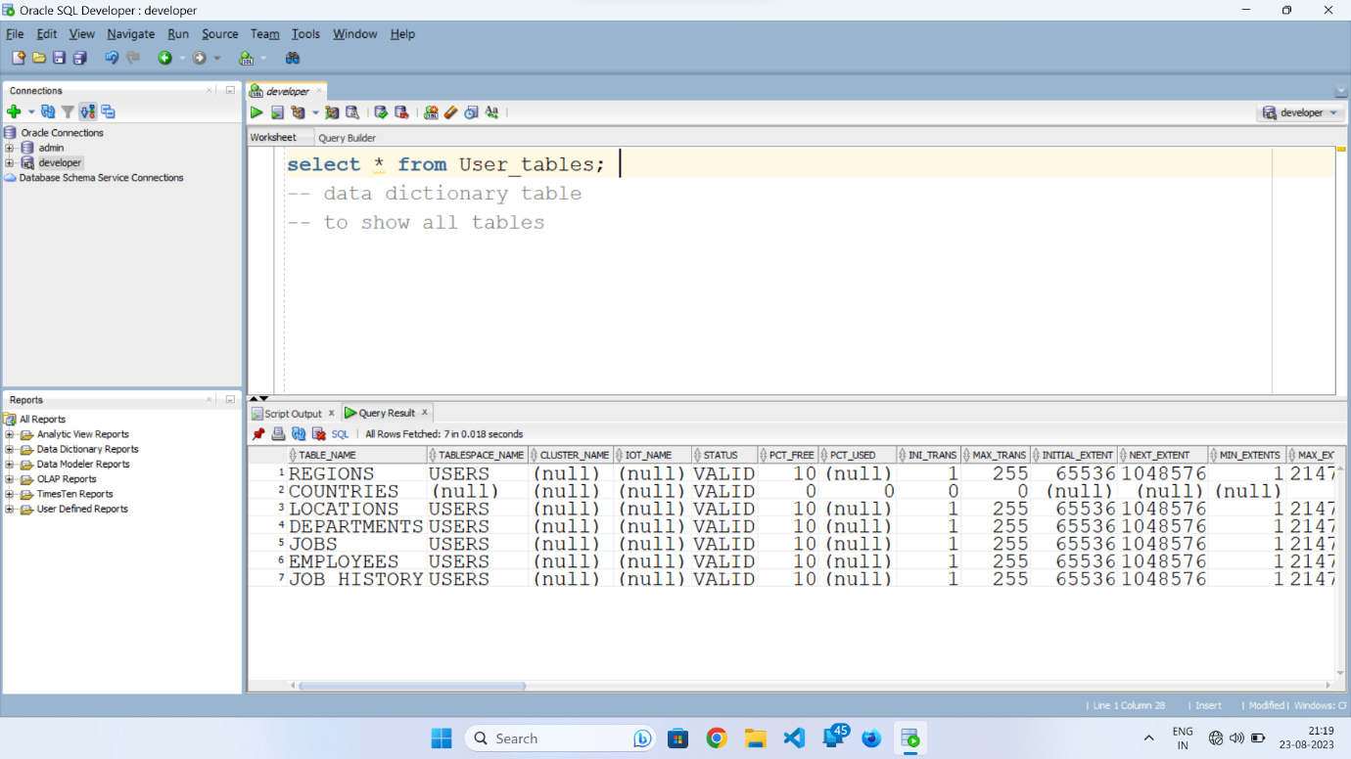

**DRL – Data Retrieval Language**

***SELECT Clause:***

To Retrieve or view the data in a particular table.

**Syntax 1**:

SELECT * FROM TABLE_NAME;

SELECT, FROM – is a keyword

**\* -**  to retrieve all row’s and all column’s.

**Syntax 2**:

SELECT COLUMN1, COLUMN2 FROM TABLE_NAME;

**Example 1:**

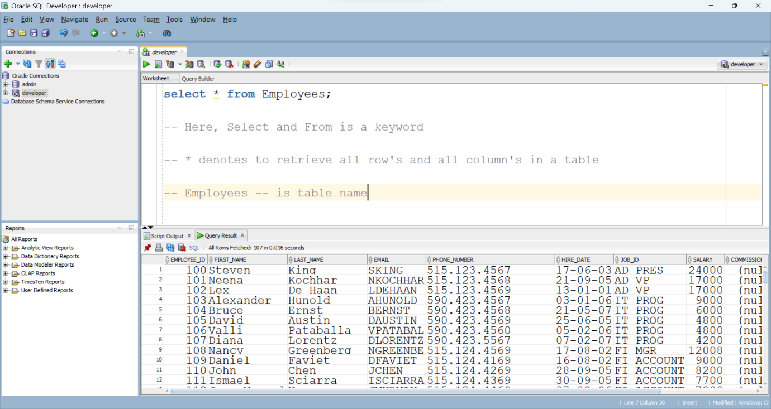

Example 2:

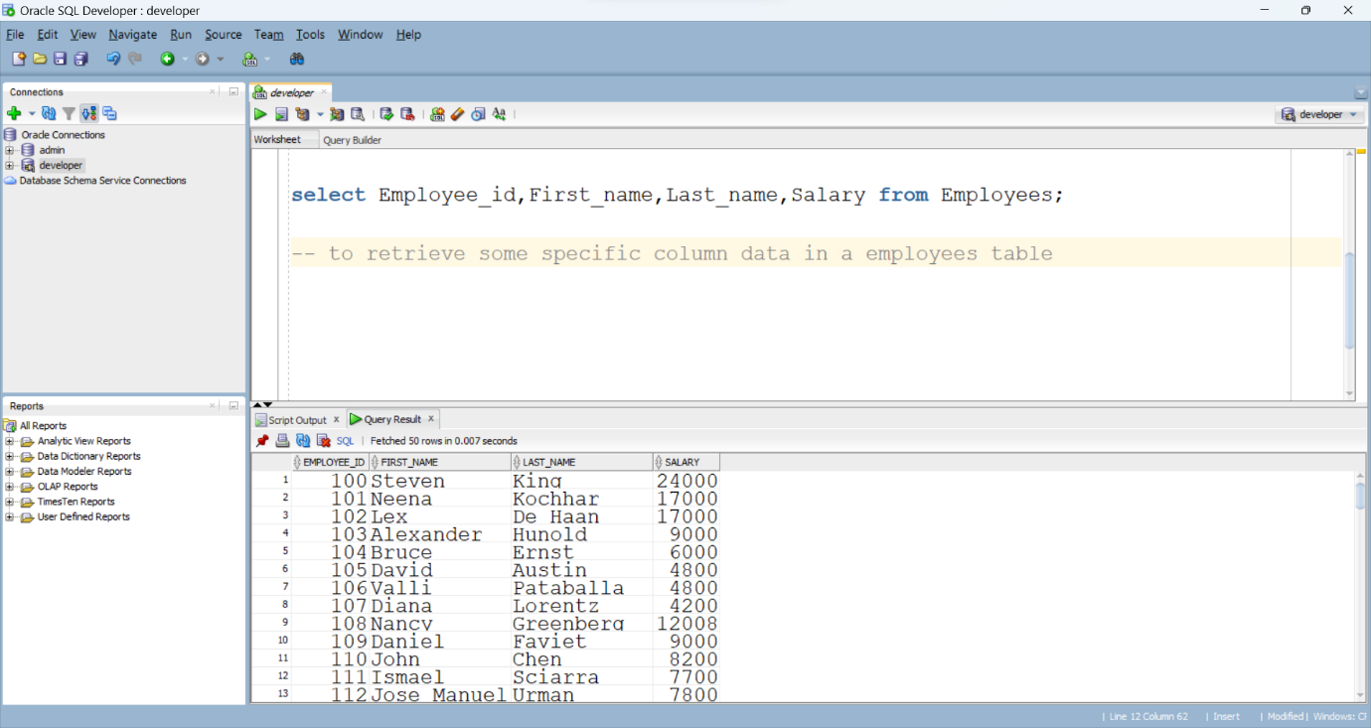

**DDL – Data Definition Language**

**1. Create**

**2. Alter**

**3. Rename**

**4. Truncate**

**5. Drop**

**1.Create –** used to create new things like tables.

Syntax:

CREATE Table Table_name(

columnName datatype;

columnName datatype(size);

);

Example:

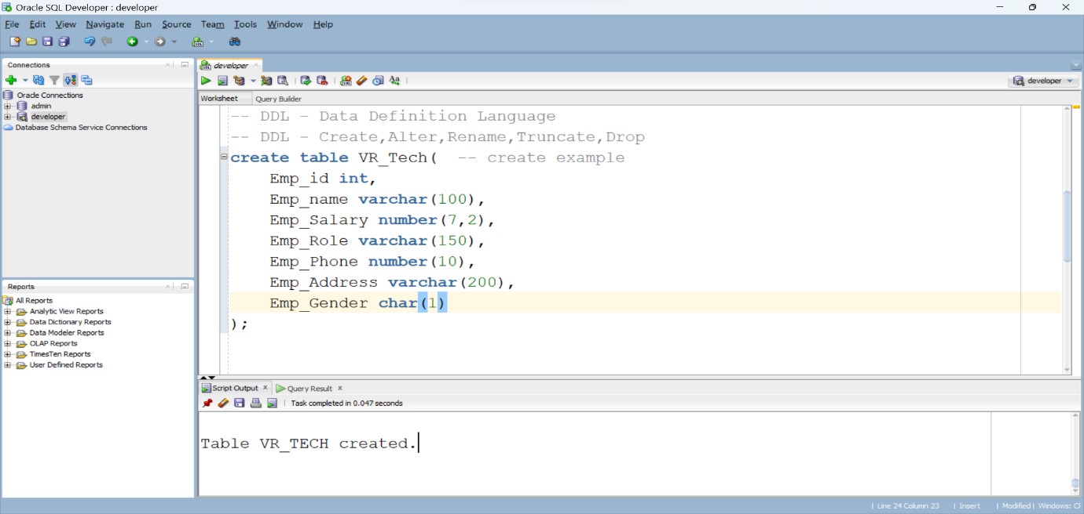

To check table is created or not;

Select * from VR_TECH;

Example:

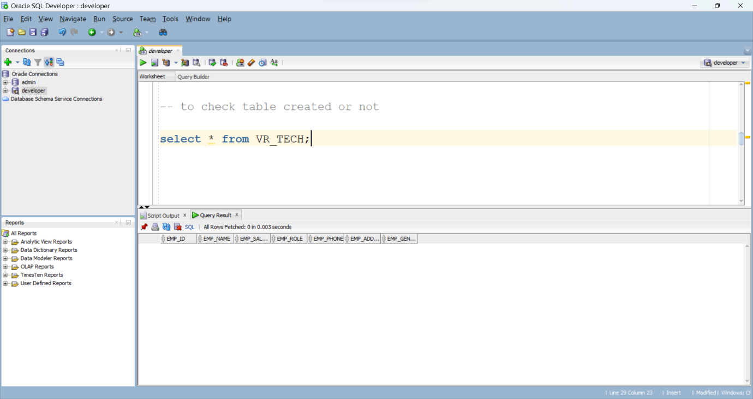

**Alter:** used to alter the table like change datatype, add column’s, rename the column…

Alter:

1.Add,

2.Rename Column,

3.Drop Column,

4.Modify

Syntax: ADD

Alter table tableName add newColumnName datatype;

Example: ADD

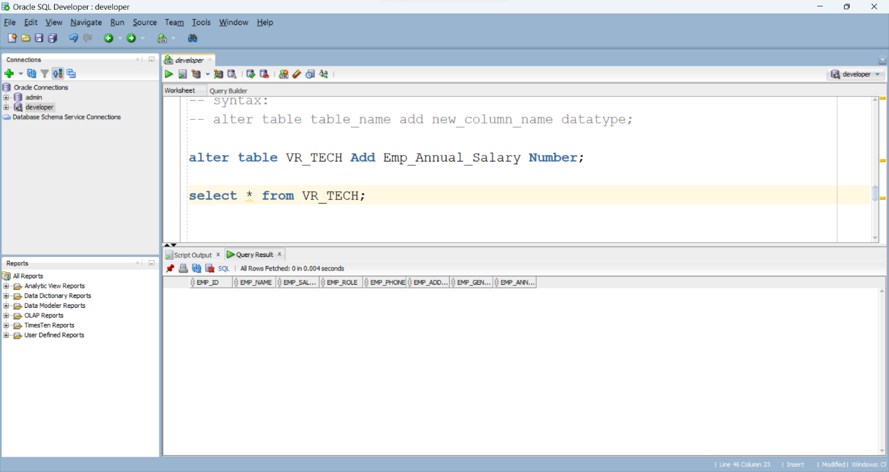

Syntax: MODIFY

Alter table tableName Modify columnName newDatatype;

Example: MODIFY

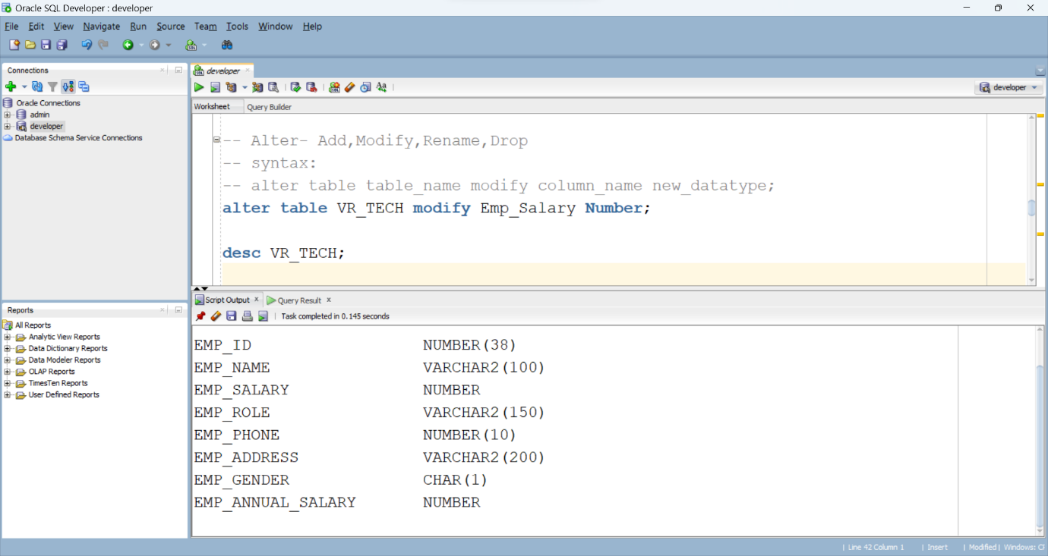

Syntax: RENAME COLUMN

Alter table tableName Rename Column oldColumnName to NewColumnName;

Example: RENAME COLUMN

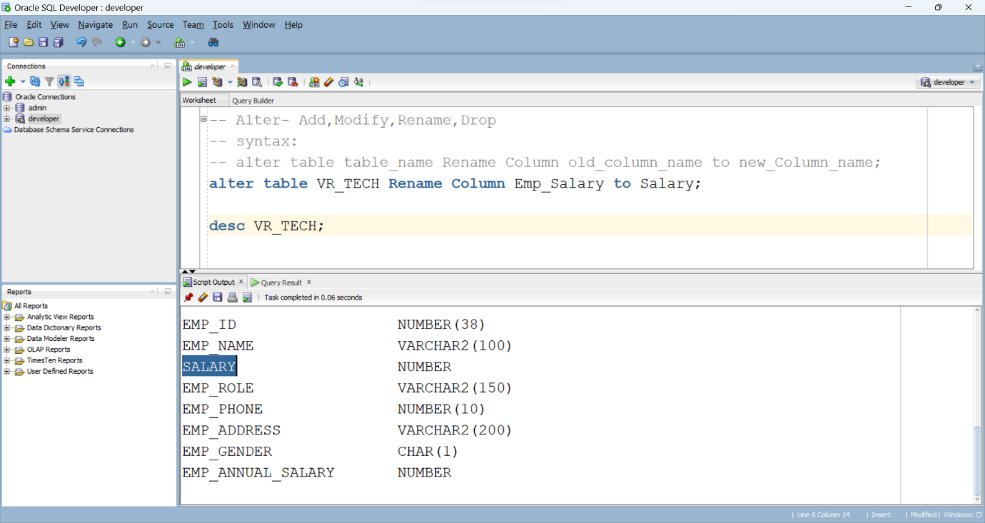

Syntax: DROP COLUMN

Alter table TableName Drop Column ColumnName;

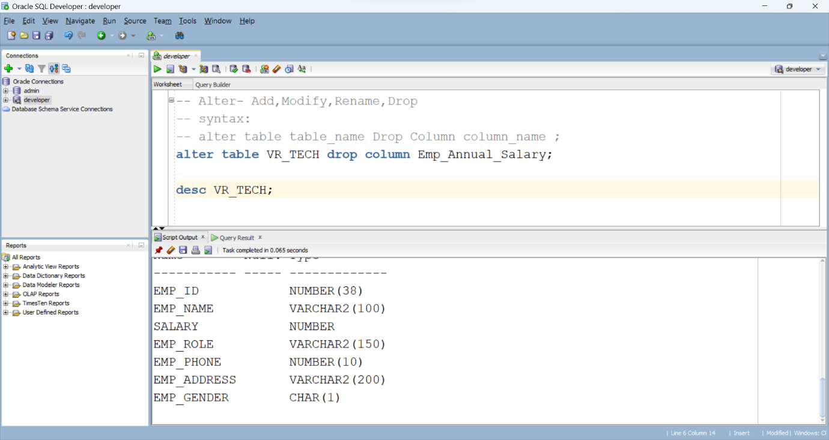

**Truncate:**

Truncate – it’s used delete/remove entire data in the table. It, Remains only Structure.

* We can’t delete specific row with this method.
* It’s Auto commit;

Syntax:

Truncate Table Table_Name;

**Drop:**

Drop – it’s used to delete entire data and structure in the table. It remains nothing.

Syntax:

Drop Table Table_Name;

**Rename:**

Rename: it’s used change the name of the table

Syntax:

Rename Old_tableName to New_tableName;

**DML – Data Manipulation Language**

1. Insert
2. Update
3. Delete
4. Merge

Insert:

Insert new things into existing table;

Syntax 1:

INSERT INTO TableName Values (All Data’s);

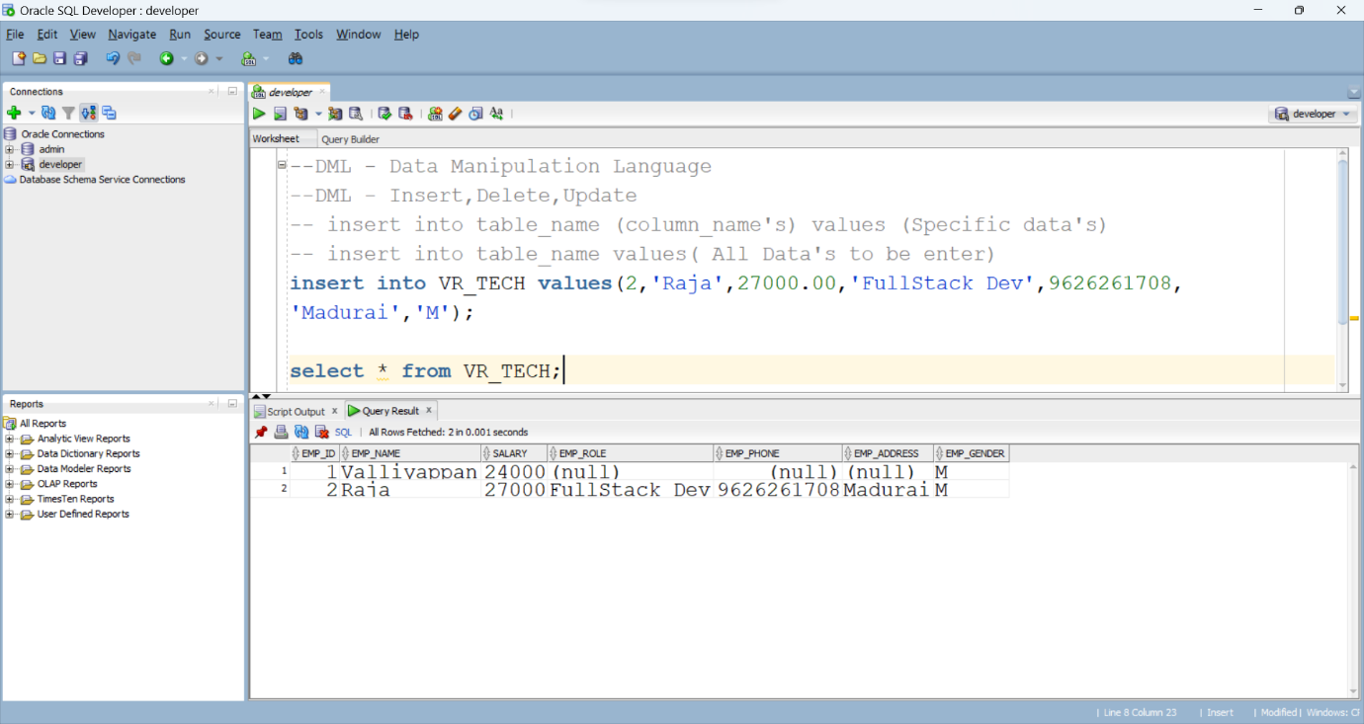

Syntax 2:

INSERT INTO TableName (specific column’s) Values (specified column data’s)

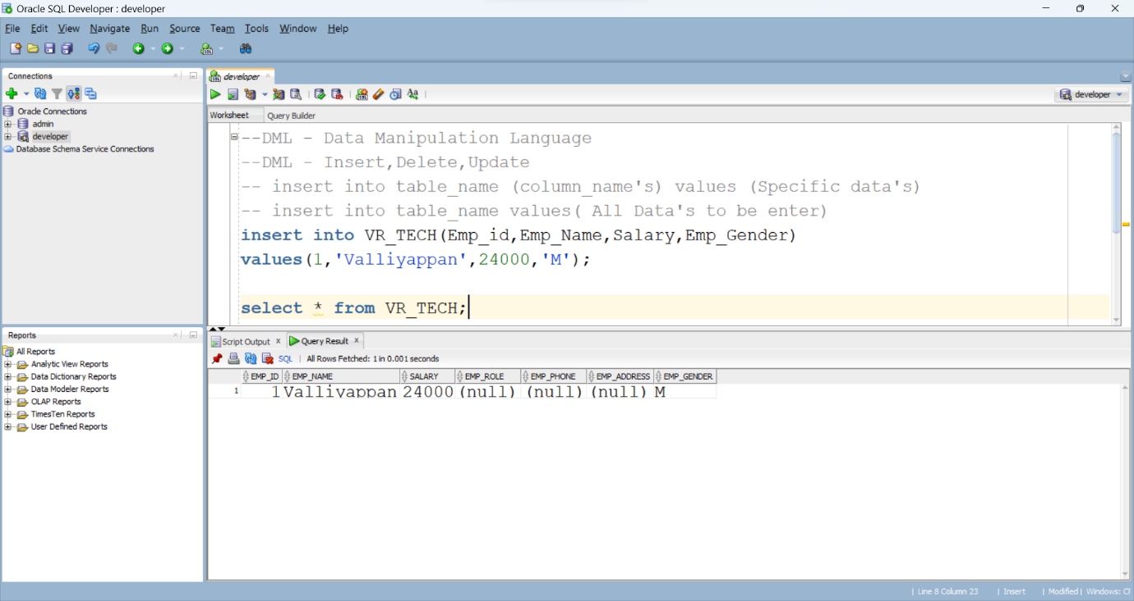

2.Update – Update / Change the existing table records

Syntax:

Update tableName set column_name = value where condition;

Example:

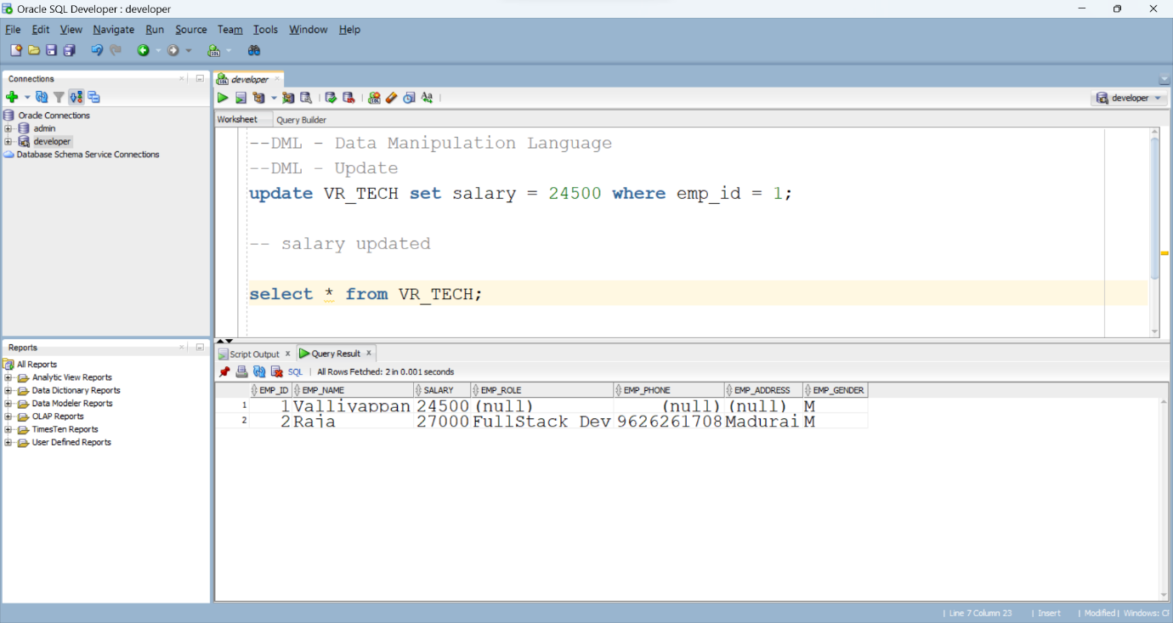

Delete – Delete/Remove Existing data in a table

Syntax:

Delete From TableName where condition;

